- Purpose

The purpose of this policy is to introduce new full-time employees to Giles Chemical’s policy regarding when and where safety glasses and safety shoes are to be worn and reimbursement for such.

- Scope

All Giles employees will be required to wear safety glasses and safety shoes when working in production areas. Safety shoes shall comply with ANSI Z41.1 and ASTM F2413-05 safety standards (Steel-toed or composite work boots or shoes).

Reimbursements for safety glasses and safety shoes will be honored during an employee’s new hire probationary period (90 days). However, if the reimbursed employee should not complete the probationary period, any monies reimbursed will be deducted from the employee’s final paycheck.

- Responsibility

Safety Department is responsible for overseeing this program.

All employees are responsible for turning in their receipt to the Safety Department in a timely manner.

- Safety Considerations

Safety glasses and appropriate safety apparel are to be worn at all times.

Safety is a condition of employment. Employees are not authorized to work in an unsafe manner and are prohibited from harming the environment of the facility or community.

- Materials/Equipment-

N/A

- Policy:

- Safety Shoes

All Giles employees will be required to wear safety shoes (steel-toed or composite work boots or shoes) when working in the production areas (Manufacturing, Repackaging and warehouses). Administrative employees are also required to wear safety shoes when working in the production areas. Safety shoes shall comply with ANSI Z41.1 and ASTM F2413-05 safety standards. Safety shoes are not required (safety glasses are required) in designated safety areas by employees or visitors (see attached diagram).

Giles will reimburse employees for safety shoes every calendar year (2013, 2014, 2015…..) up to fifty dollars ($50) or twenty-five dollars ($25) twice a year. However, Manufacturing hourly employees and supporting Maintenance will be reimbursed up one hundred dollars ($100) or fifty dollars ($50) twice a year due to the harsh wet walking surfaces.

Employee is to promptly submit their receipt to the Quality/Safety Department for reimbursement and retain a copy for their records. At that time a Reimbursement Request form will be completed and submitted to Accounting. The payables process generally takes at least two weeks.

- Safety Glasses

All Giles Chemical employees will be issued a pair of non-prescription safety glasses to be worn at all times in the production areas (Manufacturing, Repackaging and warehouses). Replacement of non-prescription safety glasses may be obtained from the Quality/Safety Department.

An employee who requires prescription safety glasses will be allotted up to $225.00 every two years for a single pair of glasses. The Quality/Safety Department will provide these employees with a voucher for the purchase of prescription safety glasses through Wal-mart Vision Center. Glasses are to be chosen from styles available through a contract with this vendor. If an employee needs special glasses outside of the contract, it must be approved by the Quality/Safety Department or Human Resources. Giles Chemical will reimburse employees who choose to buy glasses through a vision center of their choice. Employees will be responsible for payment for their own eye exams.

- Designated Safety Areas

There are designated safe areas in the Manufacturing production area. These areas are demarcated by signs and/or physical barriers and outlined as such by the attached "Designated Safety Area" diagram. Safety glasses must be worn in these areas but safety shoes may or may not be a requirement. Both safety glasses and safety shoes are required to be worn throughout the Repackaging facility.

Any and all persons not employed by Giles but entering the facility will be expected to follow the safety guidelines outlined by Giles.
Visitors must sign in, be met by their contact at Giles and accompanied to their designation donning the appropriate personal protection equipment (safety glasses, safety shoes, etc.). Please ensure that visitor safety glasses are returned to the front office and that the visitor signs out.

Contractors will be given a brief safety orientation before they are allowed to perform their duties. Contractors are responsible for providing their own personal protection equipment.
Truck drivers will be expected to follow the safety guidelines outlined by Giles. Truck drivers will only be permitted in designated areas and are not allowed to venture through the plant.

MAIN PLANT SAFETY DIAGRAM

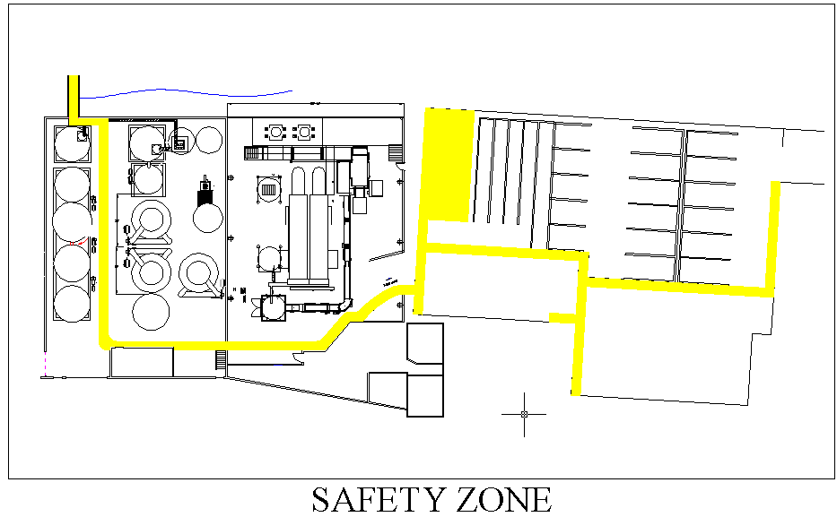
- Reference Documents

N/A

- Change Information

Revised safety shoe reimbursement amounts for Manufacturing and supporting Maintenance employees.

